

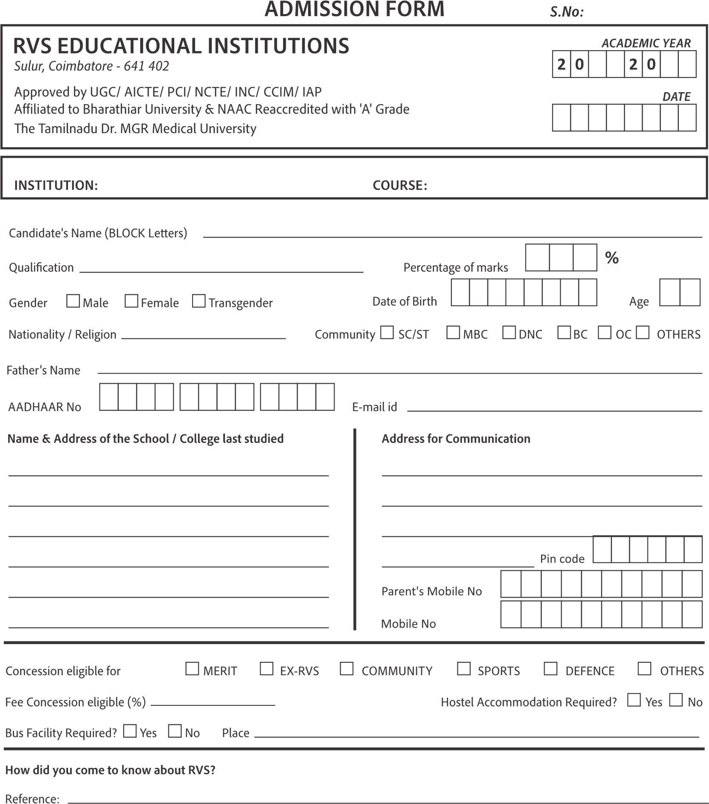

Affiliated to UGC/NCVT/NSDC/DTET- SCTE&VT, Odisha /BOPT,

Govt of India/SUVU University Admission centre

**Shree Jagannath Group of Institute**

**j**

Jyoti Vihar Complex, Jagatpur, Cuttack ,Odisha-754021